Instruction for Installing the NCHS Book 1 Set (Web-Install)

Book 1 is available online at: http://www.cdc.gov/nchs/about/major/dvs/medsof.htm

To install the program, the setup files must first be extracted to the hard drive.

Click on the Book1 link on that page will display the program Book1.Exe.
Double Click on the Book1.Exe program to begin extracting the setup files to your hard drive. The following screen will appear.

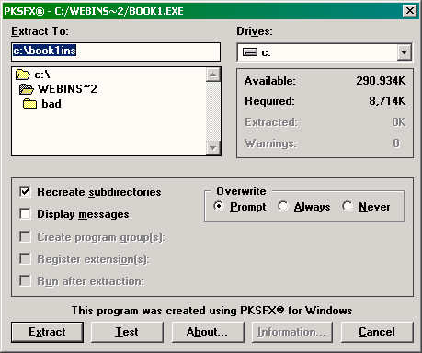

The default setup will extract the necessary files to c:\book1ins. This can be changed by typingin a different path in the “Extract to” field. These files are temporary and should be deleted once installations are complete.

Click on the Extract button in the lower left to proceed.

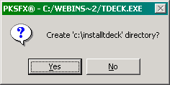
Click “Yes” to create the folder.
It should take only a few seconds to extract the files. When complete, the PKSFX dialog will vanish.

Use My Computer or Windows Explorer to open C:\book1ins and double-click on setup.exe to begin installation.

